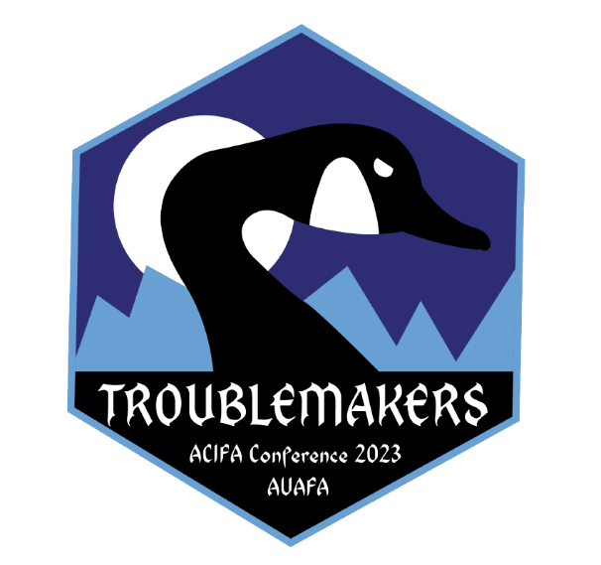

Call for Submissions
Submission Deadline January 13, 2023
  - You will be notified by mid-February about the status of your proposal.
  - Sessions will be scheduled for Monday, May 8 and Tuesday, May 9.
  - Please provide a headshot and bio of no more than 100 words as part of your submission.
admin@acifa.ca
For more information, contact the ACIFA office through the email
address listed above or by phone: (780) 423-4440

********************************************************************************************

Alberta Colleges & Institutes Faculties Association
2023 Annual Spring Conference: May 7-9, 2023

Taking place at Chateau Lake Louise and

hosted by Alberta University of the Arts Faculty Association

Our theme takes inspiration from the many troublemakers throughout history, who in spite of being told to be quiet and not to cause a scene, are compelled to follow the pursuit of justice and equality for all.

John Lewis (1940-2020), an American politician and civil rights activist spoke of the importance to engage in “good trouble” to call out injustices. In his lifetime, Lewis was a key player in the US civil rights movement and contributed to ending legalized racial segregation.

“Do not get lost in a sea of despair. Be hopeful, be optimistic. Our struggle is not the struggle of a day, a week, a month, or a year, it is the struggle of a lifetime. Never, ever be afraid to make some noise and get in good trouble, necessary trouble.”

– John Lewis
Donna Haraway (1944), author and scholar, was the first tenured professor in the US to teach feminist theory. In her book, Staying with the Trouble: Making Kin in the Chuthucene, the author emphasizes the importance of troubling:

“Our task is to make trouble, to stir up potent response to devastating events, as well as to settle troubled waters and rebuild quiet places.”
– Donna Haraway

Taken from the Troublemakers Handbook, edited by Jane Slaughter, in the introduction, Slaughter describes the conundrum of workers who are labeled as troublemakers (by their employer’s) for standing up for their basic rights in the workplace:

"By troublemaker we mean an activist who dares to defend [their] rights and those of fellow workers."

– Jane Slaughter

Theme Strands:

- Union
How do we support connection and member engagement?
Topics may include:
-Member information sessions
-Rights
-Advocacy
-Member engagement

- Play
As the antithesis of work, play is counter intuitive to productivity, urgency and other modes of capitalist ideology.

How does play enhance learning outcomes? What does play look like in the classroom and across the institution? What are alternate forms of learning through play?

Topics may include:
-Subversive craft
-Bringing people together through play/classroom dynamics
-Humour and connection
-Alternative assessments
- Decolonizing
The idea of dismantling the domination of foreign countries. Questioning and undoing modes of colonial propaganda such as false bureaucratic urgency in institutions, hierarchal positioning, meritocracy, racism, sexism, ageism…fundamental rights for self-determination.

How can we apply Indigenous knowledge and/or alternative ways of knowing to enhance educational environments and structures while reducing institutional bureaucracy?

How can faculty support and develop meaningful shifts in the organizational structure of classrooms?

Topics may include:
-Alternative assessments
-Indigenous- lead discussions on knowledge and stewardship
-Listening and learning
-Non-hierarchal- new organizational structure of classrooms

- Other

Session Coordinator/Presenter:
Name:
Institution & Department:

E-mail:
Phone:

Co-Presenter:
Name:
Institution & Department:

E-mail:
Phone:

Co-Presenter:
Name:
Institution & Department:

E-mail:
Phone:

Strand
- Union
- Play
- Decolonizing
- Other _________________________

Identify Strand:

Session Title (maximum 10 words):

25-word summary of your presentation. (This will appear in the conference program.)

Session Format: (select one)
- Panel w/papers
- Panel Discussion
- Lecture
- Demonstration
- Activity
- Workshop
- Other _______________________

Session Format Choice:

Session Length: (all sessions are to be an hour unless it’s an activity)

60 minutes – requires technology (presenter brings own laptop)

60 minutes – no technology

90 minutes – requires technology (presenter brings own laptop)
- 90 minutes – no technology
- Other ____________________
(All times to include presentation and question periods where applicable.)

Abstract (maximum 300 words):

Presentation Activities, if applicable.

Additional Information for Session Presenters:

  - Session presenters who choose to attend the whole conference must submit a CONFERENCE REGISTRATION FORM. Presenters are responsible for paying their own registration costs entirely.

  - All session presenters, co-presenters/panel members are responsible for booking and paying for their own accommodation entirely. Presenters, co-presenters, and panel members are required to book and pay for their own guestroom at the Fairmont Chateau Lake Louise for all of the nights they’ll need. Please indicate that you are with the ACIFA Conference to obtain the special conference rate.

  - All session presenters, co-presenters/panel members are also responsible for their own travel and other related costs.

